**Compiler**

**Term Project #1**

*Implementation of a lexical analyzer*

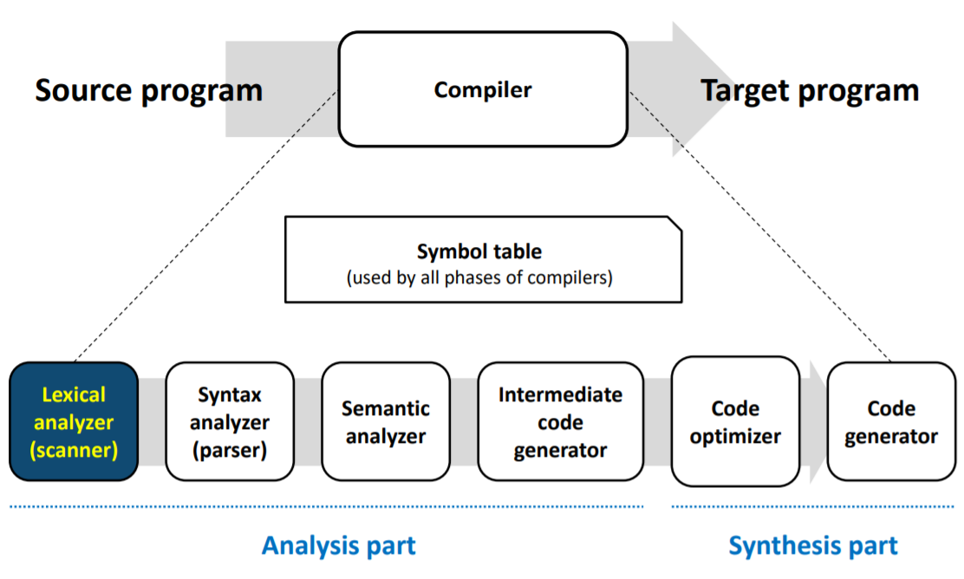

1. **Definition of tokens and regular expressions**

|  |  |  |
| --- | --- | --- |
| Token name | Value examples | Regular Expression |
| VAR | int, INT | int|INT |
| CHAR | char, CHAR | char|CHAR |
| INTVAL | 0, -1, 10, -20, 999 | 0|((-|ε)nzdigit digit*) |
| CHARVAL | "I am 20 years old" | "(digit|letter|blank)*" |
| ID | func1, i, foo | letter(letter|digit)* |
| IF | if, IF | if|IF |
| ELSE | else, ELSE | else|ELSE |
| WHILE | while, WHILE | while|WHILE |
| RETURN | return, RETURN | return|RETURN |
| OP | +, -, *, / | +|-|*|/ |
| ASSIGN | = | = |
| COMP | <, >, ==, !=, <=, >= | ((<|>|=|!)=)|<|> |
| TERM | ; | ; |
| LSCOPE | { | { |
| RSCOPE | } | } |
| LPAREN | ( | ( |
| RPAREN | ) | ) |
| COMMA | , | , |
| WSPACE | \t, \n, blank | (\t|\n|blank)+ |

**Alphabets**

digit = {0, 1, 2, 3, 4, 5, 6, 7, 8, 9}

nzdigit = {1, 2, 3, 4, 5, 6, 7, 8, 9}

letter = {a, b, c, d, e, f, g, h, I, j, k, l, m, n, o, p, q, r, s, t, u, v, w, x, y, z,   
A, B, C, D, E, F, G, H, I, J, K, L, M, N, O, P, Q, R, S, T, U, V, W, X, Y, Z}

1. **NFA & DFA**

**INT**

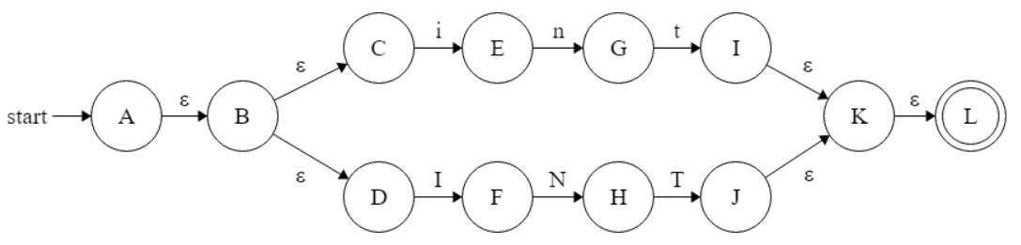

|  |  |  |  |  |  |  |
| --- | --- | --- | --- | --- | --- | --- |
|  | i | n | t | I | N | T |
| T0 | T1 |  |  | T4 |  |  |
| T1 |  | T2 |  |  |  |  |
| T2 |  |  | T3 |  |  |  |
| T3 |  |  |  |  |  |  |
| T4 |  |  |  |  | T5 |  |
| T5 |  |  |  |  |  | T6 |
| T6 |  |  |  |  |  |  |

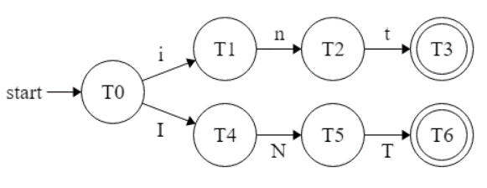

**CHAR**

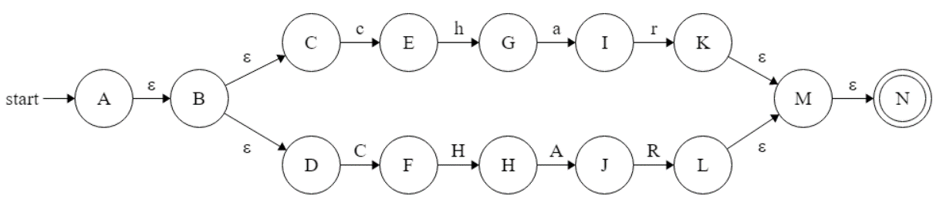

|  |  |  |  |  |  |  |  |  |
| --- | --- | --- | --- | --- | --- | --- | --- | --- |
|  | c | h | a | r | C | H | A | R |
| T0 | T1 |  |  |  | T5 |  |  |  |
| T1 |  | T2 |  |  |  |  |  |  |
| T2 |  |  | T3 |  |  |  |  |  |
| T3 |  |  |  | T4 |  |  |  |  |
| T4 |  |  |  |  |  |  |  |  |
| T5 |  |  |  |  |  | T6 |  |  |
| T6 |  |  |  |  |  |  | T7 |  |
| T7 |  |  |  |  |  |  |  | T8 |
| T8 |  |  |  |  |  |  |  |  |

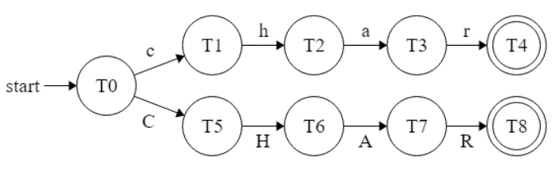

**INTVAL**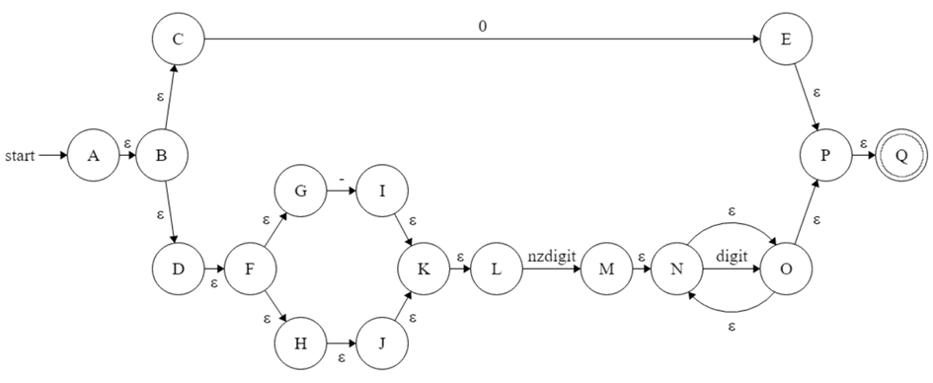

|  |  |  |  |  |
| --- | --- | --- | --- | --- |
|  | 0 | - | nzdigit | digit |
| T0 | T1 | T2 | T3 |  |
| T1 |  |  |  |  |
| T2 |  |  | T3 |  |
| T3 |  |  |  | T4 |
| T4 |  |  |  | T4 |

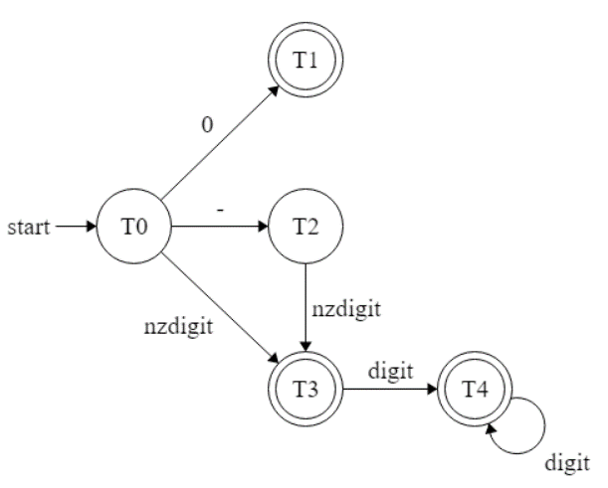

**CHARVAL**

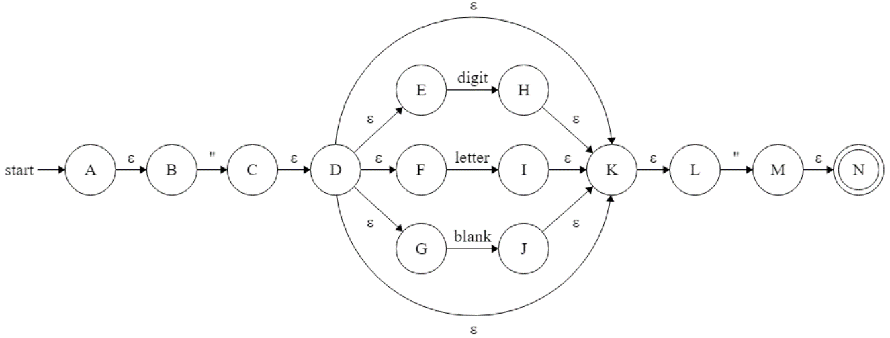

|  |  |  |  |  |
| --- | --- | --- | --- | --- |
|  | " | digit | letter | blank |
| T0 | T1 |  |  |  |
| T1 | T5 | T2 | T3 | T4 |
| T2 | T5 | T2 | T3 | T4 |
| T3 | T5 | T2 | T3 | T4 |
| T4 | T5 | T2 | T3 | T4 |
| T5 |  |  |  |  |

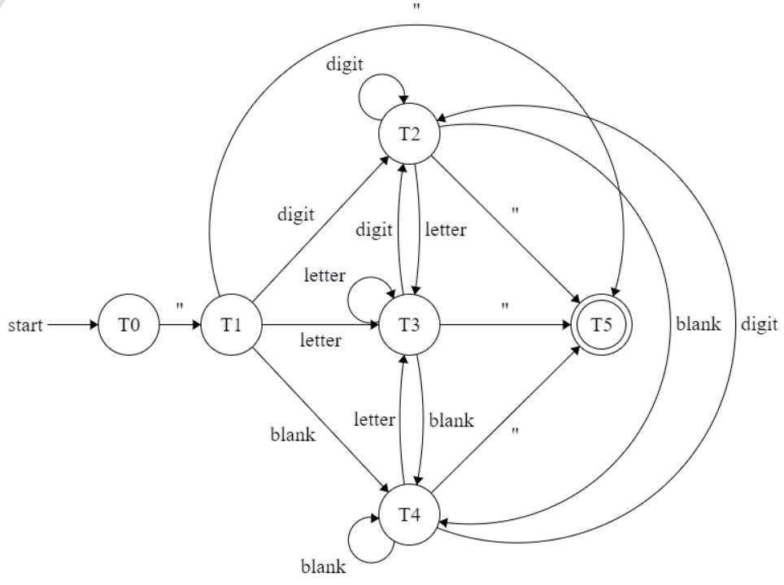

**ID**

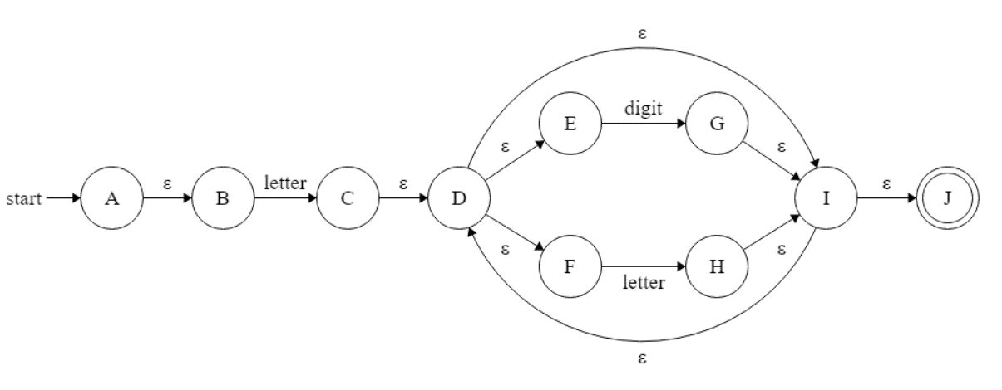

|  |  |  |
| --- | --- | --- |
|  | letter | digit |
| T0 | T1 |  |
| T1 | T3 | T2 |
| T2 | T3 | T2 |
| T3 | T3 | T2 |

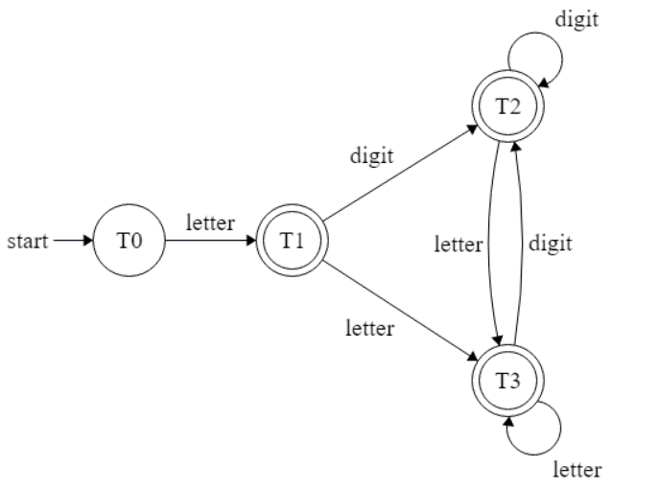

**IF** 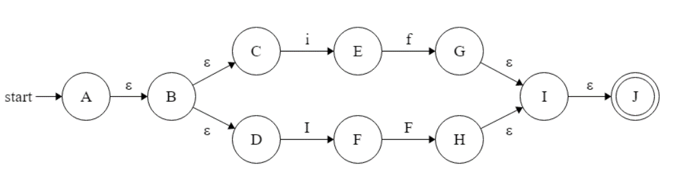

|  |  |  |  |  |
| --- | --- | --- | --- | --- |
|  | i | f | I | F |
| T0 | T1 |  | T3 |  |
| T1 |  | T2 |  |  |
| T2 |  |  |  |  |
| T3 |  |  |  | T4 |
| T4 |  |  |  |  |

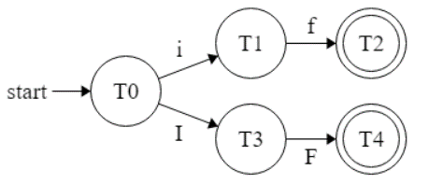

**ELSE** 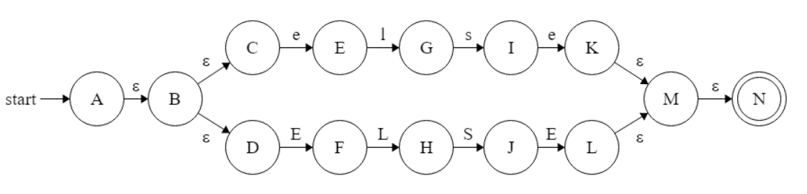

|  |  |  |  |  |  |  |  |  |
| --- | --- | --- | --- | --- | --- | --- | --- | --- |
|  | e | l | s | e | E | L | S | E |
| T0 | T1 |  |  |  | T5 |  |  |  |
| T1 |  | T2 |  |  |  |  |  |  |
| T2 |  |  | T3 |  |  |  |  |  |
| T3 |  |  |  | T4 |  |  |  |  |
| T4 |  |  |  |  |  |  |  |  |
| T5 |  |  |  |  |  | T6 |  |  |
| T6 |  |  |  |  |  |  | T7 |  |
| T7 |  |  |  |  |  |  |  | T8 |
| T8 |  |  |  |  |  |  |  |  |

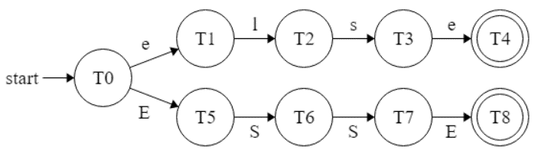

**WHILE** 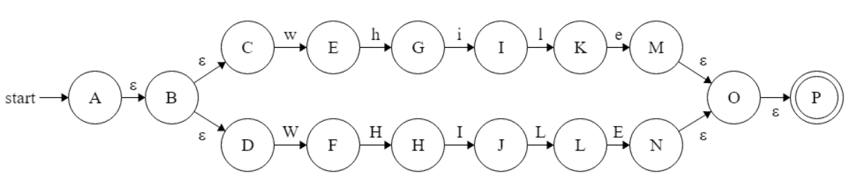

|  |  |  |  |  |  |  |  |  |  |  |
| --- | --- | --- | --- | --- | --- | --- | --- | --- | --- | --- |
|  | w | h | i | l | e | W | H | I | L | E |
| T0 | T1 |  |  |  |  | T6 |  |  |  |  |
| T1 |  | T2 |  |  |  |  |  |  |  |  |
| T2 |  |  | T3 |  |  |  |  |  |  |  |
| T3 |  |  |  | T4 |  |  |  |  |  |  |
| T4 |  |  |  |  | T5 |  |  |  |  |  |
| T5 |  |  |  |  |  |  |  |  |  |  |
| T6 |  |  |  |  |  |  | T7 |  |  |  |
| T7 |  |  |  |  |  |  |  | T8 |  |  |
| T8 |  |  |  |  |  |  |  |  | T9 |  |
| T9 |  |  |  |  |  |  |  |  |  | T10 |
| T10 |  |  |  |  |  |  |  |  |  |  |

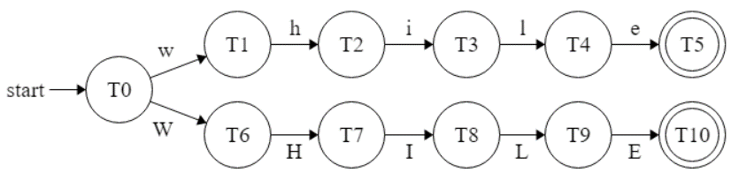

**RETURN** 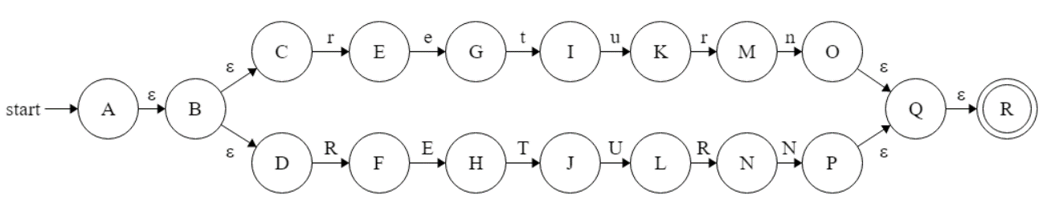

|  |  |  |  |  |  |  |  |  |  |  |  |  |
| --- | --- | --- | --- | --- | --- | --- | --- | --- | --- | --- | --- | --- |
|  | r | e | t | u | r | n | R | E | T | U | R | N |
| T0 | T1 |  |  |  |  |  | T7 |  |  |  |  |  |
| T1 |  | T2 |  |  |  |  |  |  |  |  |  |  |
| T2 |  |  | T3 |  |  |  |  |  |  |  |  |  |
| T3 |  |  |  | T4 |  |  |  |  |  |  |  |  |
| T4 |  |  |  |  | T5 |  |  |  |  |  |  |  |
| T5 |  |  |  |  |  | T6 |  |  |  |  |  |  |
| T6 |  |  |  |  |  |  |  |  |  |  |  |  |
| T7 |  |  |  |  |  |  |  | T8 |  |  |  |  |
| T8 |  |  |  |  |  |  |  |  | T9 |  |  |  |
| T9 |  |  |  |  |  |  |  |  |  | T10 |  |  |
| T10 |  |  |  |  |  |  |  |  |  |  | T11 |  |
| T11 |  |  |  |  |  |  |  |  |  |  |  | T12 |
| T12 |  |  |  |  |  |  |  |  |  |  |  |  |

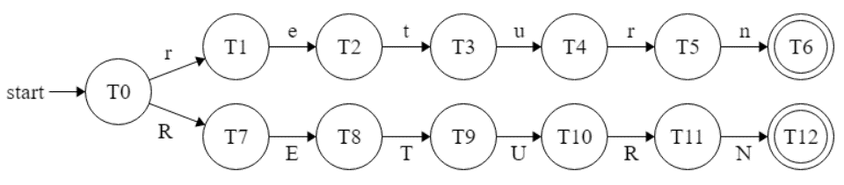

**OP**

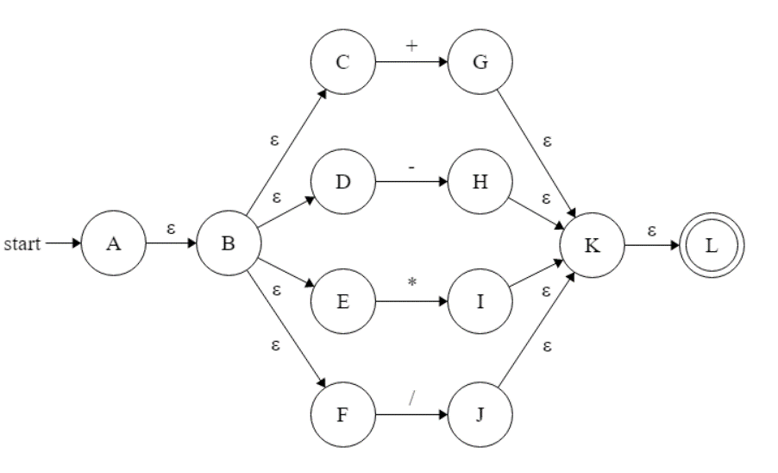

|  |  |  |  |  |
| --- | --- | --- | --- | --- |
|  | + | - | * | / |
| T0 | T1 | T2 | T3 | T4 |
| T1 |  |  |  |  |
| T2 |  |  |  |  |
| T3 |  |  |  |  |
| T4 |  |  |  |  |

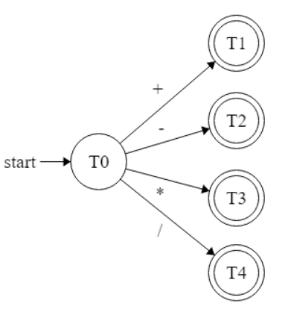

**COMP**

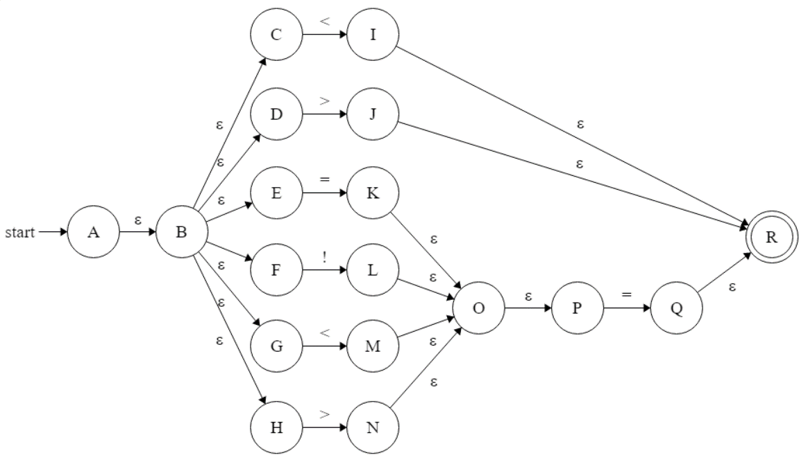

|  |  |  |  |  |
| --- | --- | --- | --- | --- |
|  | < | > | = | ! |
| T0 | T1 | T2 | T3 | T4 |
| T1 |  |  | T5 |  |
| T2 |  |  | T5 |  |
| T3 |  |  | T5 |  |
| T4 |  |  | T5 |  |
| T5 |  |  |  |  |

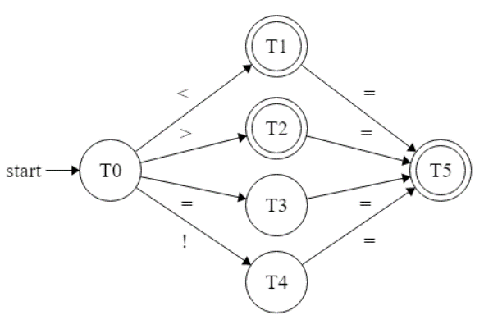

**WSPACE**

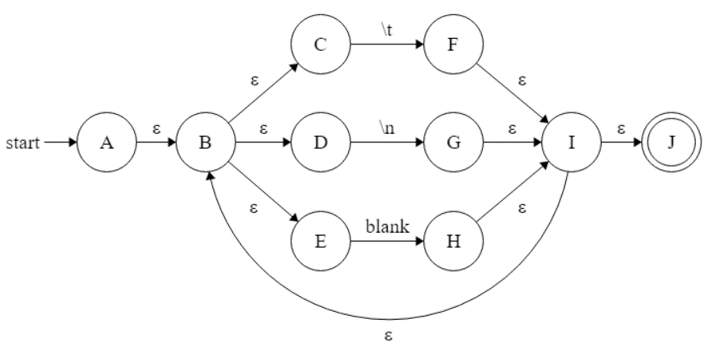

|  |  |  |  |
| --- | --- | --- | --- |
|  | \t | \n | blank |
| T0 | T1 | T2 | T3 |
| T1 | T1 | T2 | T3 |
| T2 | T1 | T2 | T3 |
| T3 | T1 | T2 | T3 |

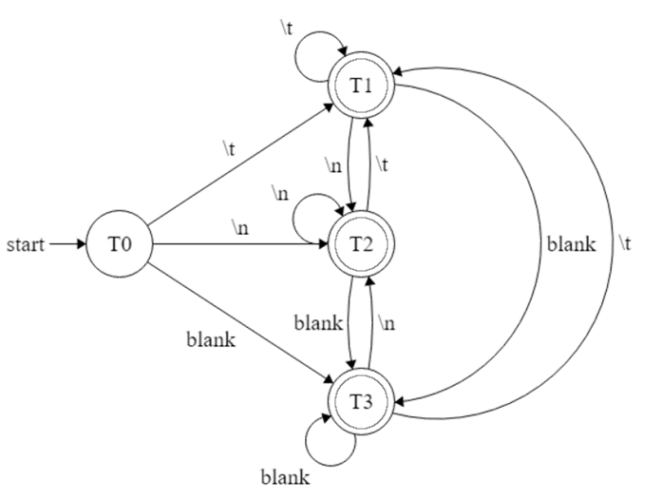

**ASSIGN**

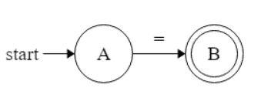

|  |  |
| --- | --- |
|  | = |
| T0 | T1 |
| T1 |  |

**TERM**

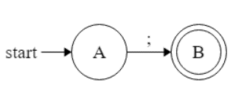

|  |  |
| --- | --- |
|  | ; |
| T0 | T1 |
| T1 |  |

**LSCOPE**

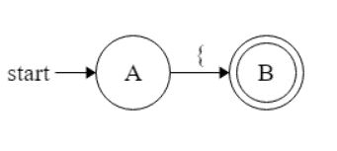

|  |  |
| --- | --- |
|  | { |
| T0 | T1 |
| T1 |  |

**RSCOPE**

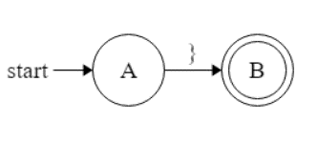

|  |  |
| --- | --- |
|  | } |
| T0 | T1 |
| T1 |  |

**LPAREN**

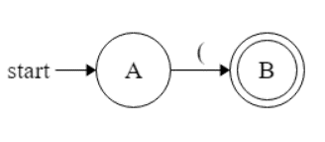

|  |  |
| --- | --- |
|  | ( |
| T0 | T1 |
| T1 |  |

**RPAREN**

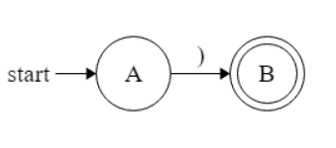

|  |  |
| --- | --- |
|  | ) |
| T0 | T1 |
| T1 |  |

**COMMA**

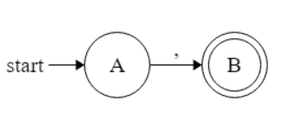

|  |  |
| --- | --- |
|  | , |
| T0 | T1 |
| T1 |  |

**Implementation of the lexical analyzer**

*Regular Expression Parser*

*token.py*

The token.py file contains token enums and their DFA table.

For each token, the DFA table is an object with “key”, “value” and “final”.

“key” is the list of characters

“value” is the value of each case

“final” is the list of all final states

*regexparser.py*

The class Regex has a method isvalid() which have in argument the string to parse and the token enum to test.

We have a loop on the string and check for each character.

For each character, we check if the character is in the DFA table. If true, we check if there is a transition state from the current state. If true, the current state is replaced by the value from the table and we go on the next string character.

If the character is not in the table: return false

If there is no transition state from the current state: return false

If the current state is not a final state: return false

*Main algorithm*

*Lexical-analyzer.py*

In this file is written the main algorithm as well as the error handling.

The algorithm consists of reading the file content with a “window” that has a variable size and to check if the string contained in this window validate some regular expression using the regexparser.py. Once that we can’t validate any regular expression with what is contained anymore, we attribute a token name to the last state of the window.

For example a string “int;” will be first read with a window of size 1, “i”, and validate a regular expression for “ID”, then we increase the window size by one, “in” validate a regular expression for “ID”, then we increase the window size by one, “int” validate both “ID” and “INT”, then “int;” doesn’t validate any regular expression anymore so we take the last state of the window with the token name that as the most “weight”, here “INT” for “int”. Then the window will start again with a size of 1 on the character “;” and so on…

Things were not easy to implement for the “CHARVAL” regular expression with this logic as the character “ is recognized as an error when read alone.

Regarding the error system: it detects if there’s any issue with the program arguments, the file management (file doesn’t exist / impossible to write / …) and the errors contained in the file. For this last case it prints the line where the error comes from and the character(s) implied in the error.